# Description

On the Rates page, the percentage value in the **Assumptions** text drops to 0% when we expect a non-zero value. This occurs after altering **Purchase price**, not altering **Estimated down payment**, and clicking **Update**.

# Reproduce

Login to Better.com as a standard user

Navigate to the Rates page

Click the “Assumptions: Purchasing a $<price>k home in Westbury, NY with <percent>% down...” button

Make sure the **Estimated** **down payment** is non-zero (i.e. $15,000 was used in the screenshots, below). If **Estimated** **down payment** is zero then change to a non-zero value, click Update and proceed

Alter the value in the **Purchase price** field. Do not alter the **Estimated down payment** field

Click Update and wait for the page to update

The percentage value in the Assumptions button text reads 0% when it should be a non-zero value

See Page 2 for Screenshots

# Screenshots

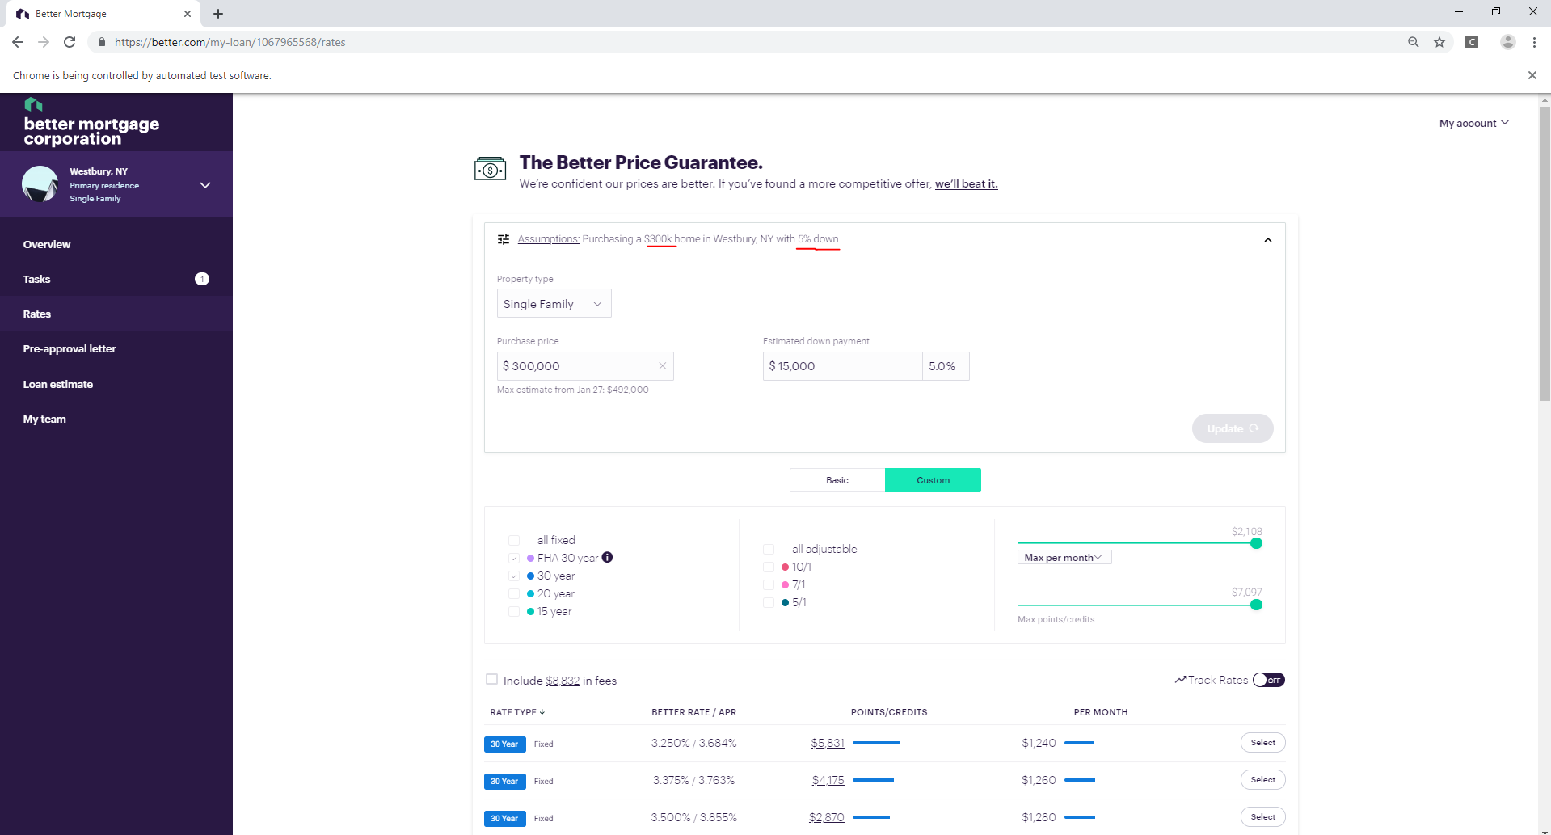

Figure 1 - **Starting Point**. Note the “300K” and “5% down” in the Assumptions text.

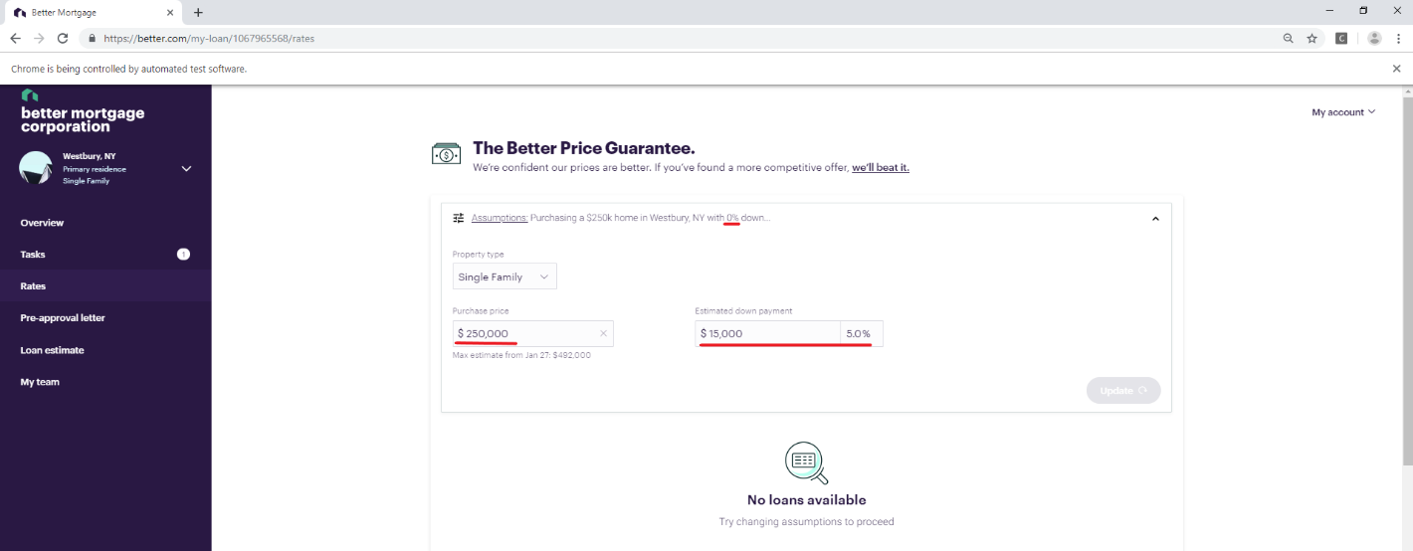

Figure 2 - After altering the **Purchase price** to $250,000 and clicking **Update** (and not altering the **Estimated down payment**), the % down in the Assumptions text goes to 0% when we expect a non-zero value.